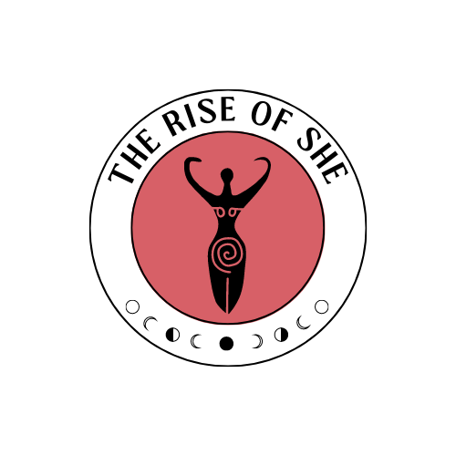

**THE RISE OF SHE CIC VULNERABLE ADULTS SAFEGUARDING POLICY**

**The Rise of She CIC** values and is committed to protecting and promoting the welfare of vulnerable adults. We recognize our responsibility to take all reasonable steps to promote safe practice and to protect vulnerable adults from harm, abuse, and exploitation.  
  
The name of the safeguarding officer is Dionne Myers, and a copy of this safeguarding policy will be kept on our website and available at the request of agencies.  
  
Purposes The purpose of The Rise of She CIC's vulnerable adult program is to offer a safe, welcoming, and supportive environment where vulnerable adults can participate in activities, receive support, and maintain their dignity and rights. This applies to all activities conducted by The Rise of She or through other independent groups working in partnership with The Rise of She.  
  
**Aims**  
- To provide inclusive activities and support services for vulnerable adults  
- To protect the rights of vulnerable adults to live in safety, free from abuse and neglect  
- To ensure that the welfare of vulnerable adults is paramount in all our activities  
- To enable vulnerable adults to express themselves and maintain their independence  
- To promote best practice in safeguarding vulnerable adults  
  
**Definition of Vulnerable Adults**

A vulnerable adult is defined as a person aged 18 or over who:  
- Has needs for care and support  
- Is experiencing, or at risk of, abuse or neglect  
- As a result of their care and support needs is unable to protect themselves from either the risk of, or the experience of abuse or neglect  
  
**Organisation**

Each vulnerable adult should be formally registered within the group. The information includes:  
- Personal details and emergency contacts  
- Relevant medical information  
- Consent forms where appropriate  
- Any specific support needs or requirements  
  
These forms contain vital information and should be kept securely and brought to each session. An exception to this is if we are running a workshop with a partner agency and they have completed this process.  
  
Safeguarding Representative The Rise of She CIC has appointed a safeguarding representative. If any worker has concerns about a vulnerable adult's safety, they should discuss them with the representative.  
  
Responsibilities of the Safeguarding Representative:  
- Ensuring the policy is being put into practice  
- Being the first point of contact for safeguarding concerns  
- Keeping a record of any concerns expressed  
- Bringing concerns to the notice of the Management Committee  
- Contacting appropriate authorities if necessary  
- Ensuring staff and volunteers receive appropriate supervision and training  
- Ensuring everyone knows the identity of the Safeguarding Representative  
  
The policy will be reviewed annually to ensure it meets its aims.  
  
**Personal/Personnel Safety**  
- Avoid being alone with a vulnerable adult unless absolutely necessary  
- If one-to-one support is required, ensure another worker knows where you are and why  
- All meetings should be planned and approved by a member of the Committee  
- Maintain appropriate professional boundaries at all times  
- Document any incidents or concerns promptly  
  
**Safe Practice Guidelines**  
- Ensure activities are appropriate and accessible  
- Maintain clear communication about the nature and expectations of all activities  
- Respect individual dignity and independence  
- Obtain consent for any photographs or videos  
- Maintain confidentiality unless there is a need to break it for safeguarding reasons  
  
**New Workers When recruiting staff and volunteers:**  
- Complete application forms  
- Conduct interviews  
- Check identity and references  
- Ensure DBS checks are completed  
- Provide appropriate training  
- Institute a probationary period  
- Provide ongoing supervision  
  
**Types of Abuse**  
- Physical abuse  
- Emotional/psychological abuse  
- Financial abuse  
- Sexual abuse  
- Neglect  
- Discriminatory abuse  
- Institutional abuse  
- Domestic violence  
- Modern slavery  
- Self-neglect  
  
Responding to Concerns If abuse is suspected or disclosed:

DO:  
- Stay calm and listen carefully  
- Take the concern seriously  
- Reassure the person  
- Record the information accurately  
- Report to the safeguarding officer immediately  
  
DON'T:  
- Promise to keep secrets  
- Be judgmental  
- Start investigating yourself  
- Discuss with anyone other than appropriate authorities  
- Delay reporting concerns  
  
**Reporting Procedures**  
1. Record the concern using the incident report form  
2. Report to the safeguarding officer immediately  
3. The safeguarding officer will decide on appropriate action  
4. If necessary, report to relevant authorities (police, social services)  
  
Safeguarding Officer Contact Details: Name: Dionne Myers Number: 07534 435 988 Address: 10 North Road, East Boldon, Tyne and Wear NE36 0DL Email: info@Riseofshe.co.uk  
  
This policy was adopted by The Rise of She CIC on 14/01/2025  
  
Signed on behalf of the Management Committee by: Name: D MYERS  
  
The policy will be reviewed by the Management Committee on: 14/01/2026